
North Bengal International University

Lab Report: 03

Exp Name : Write a program to convert your roll number into Binary number.

Subject : Computer Architecture & Organization Sessional
Subject Code : CSE 0612-3142

Submitted By:
Name : Md. Tanvir Rahman Pranto
Dept : CSE
Roll : 0712340012101005
Semester : 2nd Year, 4th semester.

Submitted To:
Name : Md. Shafiuzzaman
Designation : Lecturer
Dept : CSE
Date :

Experiment No: 03
Experiment Name: Write a program to convert your roll number into Binary number.

Theory:
When converting a decimal number (like your roll number) to binary, the most common method used is known as the "division-by-2" method. Here's how it works step by step:

1. Start with the Decimal Number:
Your roll number, which is originally given in decimal (base 10), is the number to be converted.

2. Divide by 2 and Record Remainders:
- Divide the roll number by 2.
- Write down the remainder, which will be either 0 or 1. This remainder represents one binary digit (bit).
- The quotient from this division becomes the new number to work with.

3. Repeat the Process:
Continue dividing the new quotient by 2 and record each remainder, until the quotient becomes 0. Each time, the remainder is a bit of the binary equivalent.

4. Reverse the Order of the Remainders:
The first remainder you record corresponds to the least significant bit (LSB) of the binary number. To get the correct binary number, the list of remainders must be read in reverse order (from the last remainder obtained to the first).

5. Resulting Binary Number:
The reversed sequence of remainders forms the complete binary representation of your roll number, which is the language understood by computers.

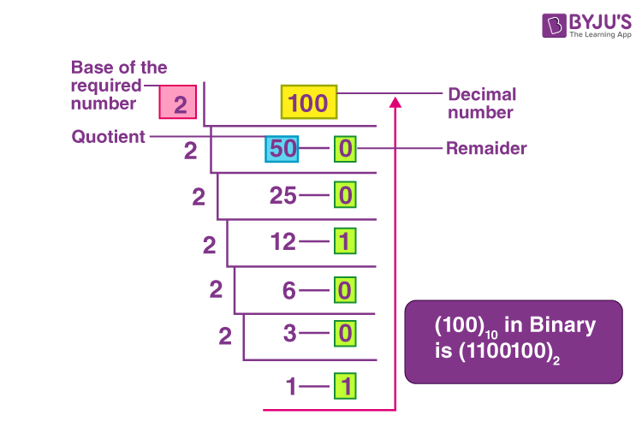
Process:

Code:
#include <stdio.h>

int main() {
int num, temp;
int index = 0, i;
int binary[32];

printf("Enter your roll number: ");
scanf("%d", &num);

if (num == 0) {
printf("Binary representation: 0\n");
return 0;
}

temp = num;
while (temp > 0) {
binary[index] = temp % 2;
temp = temp / 2;
index++;
}

printf("Binary representation: ");
for (i = index - 1; i >= 0; i--) {
printf("%d", binary[i]);
}
printf("\n");

return 0;
}

Output:
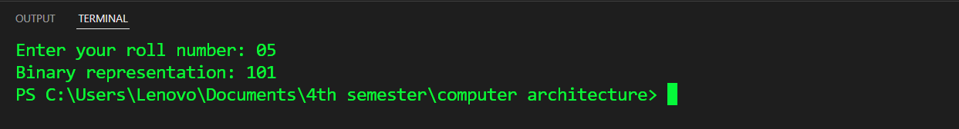

Conclusion: This simple program demonstrates an elegant way to convert a decimal roll number into its binary representation by repeatedly dividing by 2 and recording remainders. Its clear, minimalist design showcases how basic arithmetic and iterative processes can effectively solve a fundamental problem in computer science.

